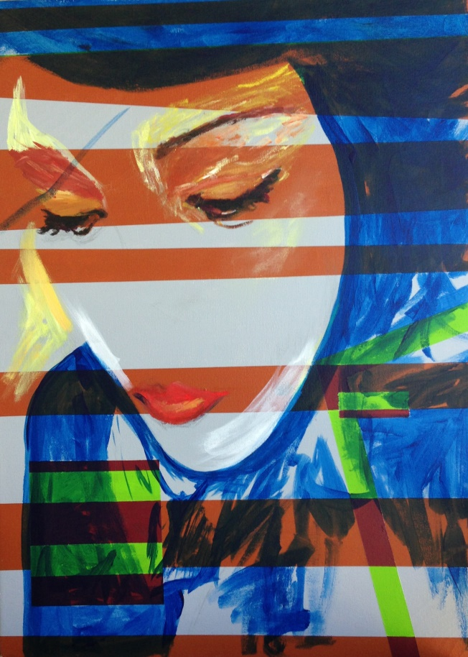
Self Portrait. Acrylic on Canvas.
Name: Suzannah McEntire
Current Position: Graduate Student, Art Education, University of Florida
Current Employment: Program Assistant, South Carolina Department of Education, Columbia, SC
Phone: 803-467-2556
Email: xannahmac@gmail.com
Web address: http://www.artsuz.com
Facebook: www.facebook.com/suzannah.mcentire
Twitter name: https://twitter.com/xannahmac

Research Interests
Italian Renaissance Painting, Expressionism, and Art Therapy

Degrees
Master of Arts, Art Education, University of Florida, Expected 2016
Bachelor of Fine Arts, Painting, Savannah College of Art and Design, 2000

Key Professional Appointments
Xannahdu’s Faux Real Finishing and Fine Art, Columbia, S.C. President and Sole Proprietor, 1995-present.
South Carolina Department of Education, Division of School Effectiveness, Office of Educator Evaluations and Effectiveness, Program Assistant and Coordinator, 2008-present.
Selected Works
2011 Faces of Sandhill's, Group show, Columbia, SC
2010 Contemporaries’ Artist of the Year, Group show, Columbia Museum of Art, Columbia, SC
2007 Contemporaries’ Artist of the Year, Columbia Museum of Art, Columbia, SC
2003 Vivid, Group Show, Savannah Gallery, Atlanta, GA
2001 Recent Paintings, Solo Show, Asheville Area Arts Council, Asheville, NC

Leadership, Grants, and Recognitions
2007 Contemporaries’ Artist of the Year People’s Choice Award, Young Contemporaries, Juried Show, Columbia Museum of Art, Columbia, S.C.
2000 Top of Three Painters in Senior Show class of 2000, The Savannah College of Art and Design, Savannah, GA
1993 Scholastic Art Award, Blue Ribbon (Best in Show) Juried Show, Converse College, Spartanburg, SC
1992 Congressional Art Award, Group/Juried Show, Capitol Rotunda, Washington, D.C.
1992 Special Purchase Award, Heathwood Hall, Columbia, SC

Creative & Research Biography
Suzannah McEntire developed her unique color energy style in her studio art by melding a technical art education at The School of the Art Institute of Chicago (SAIC) and the Pratt Institute in Brooklyn, NY with creative innovation inspired by mentors at the famous Black House at the University of South Carolina. Her work is influenced strongly by her South Carolina heritage where she gained recognition early at a South Carolina State Fair juried show and her first one-woman show at the age of 15 at the Weekend Gallery in Columbia. She explored and expanded her artistic boundaries in Italy for a year where she became fluent in Italian, studied masterpieces and developed photography skills. More recently her work was chosen to exhibit in multiple Columbia Museum of Art Artist of the Year juried shows and she was awarded the Contemporaries’ Artist of the Year People's Choice Award.

